|  |  |  |  |  |  |  |  |  |  |  |  |  |  |  |
| --- | --- | --- | --- | --- | --- | --- | --- | --- | --- | --- | --- | --- | --- | --- |
| Post Graduate Diploma in Information Technology  “**Implementation Methodology and Process for Furniture Shopping App**”   |  |  | | --- | --- | | Paper: **IT819 Applied Project** | Assignment: **#2** | | Date Due: **25/09/2020** | Date Submitted: **25/09/2020** | | Tutor: **Oras Baker** | | | We declare that the work contained in this assignment is of our own, except where acknowledgement of the source is made. We understand that our work may be used for moderation purposes. | |  |  |  | | --- | --- | | Names: | Student ID: | | **Hai Trinh** | **2020001812** | | **Tin Win** | **2020001339** | |

Table of Contents

1 Introduction 3

2 Development methodology 3

3 Tasks list 4

3.1 Set Up Environment 4

3.2 Xcode 5

3.3 Cocoa pod 5

3.4 Control and Centralize Source Code 5

4 Setup Database Environment 5

4.1 Cloud Firestore 5

5 Repository Pattern 6

6 SwiftUI 6

7 Test-driven development (TDD) 7

8 Implementation 9

8.1 Asset 9

8.2 Design Pattern 9

8.2.1 Model-View-Controller (MVC) and Model-View-ViewModel (MVVM) 9

8.2.2 Repository Pattern 11

8.3 Test Driven Development 12

8.4 Load 3D model 13

8.5 Move and Rotate 3D model 16

8.6 Capture Screenshot 17

8.7 Change 3D model pattern 18

8.8 Add Stickers to 3D model 18

8.9 Save and Load Room 20

8.10 Display Model Dimension 23

9 Result 23

9.1 Furniture List 23

9.2 Furniture Detail 24

9.3 Cart Screen 26

9.4 Send Email 27

9.5 Place 3D Furniture Model 29

9.6 Update Patterns and Stickers 30

9.7 Moving and Rotating 3D models 32

9.8 Take Screenshot 32

9.9 Save and Load Room 33

10 Conclusion 35

11 References 35

# Introduction

This study aims to implement two applications: the non-AR Furniture Shopping app and the AR Furniture Shopping app. Notably, we plan to implement features that allow users to browse, view, and purchase furniture. Furthermore, the AR app should give users the ability to experience the virtual furniture in a real room. Various frameworks are used to develop these apps, such as SwiftUI, ARKit, and SceneKit. Moreover, different design patterns are applied, such as Repository, Model-View-Controller, and Model-View-ViewModel. Additionally, Test Driven Development is followed that aims to deliver quality and scalable applications.

# Development methodology

The article “Agile Definition” (n.d) defines Agile is a software development process which is currently practising in thousands of IT industries around the globe. Moreover, Agile transformed a traditional software development process, the objective of the agile is that releasing the project partially and continually within the short time frame instead of releasing the project when the entire project is completed (Agile Definition, n.d.).

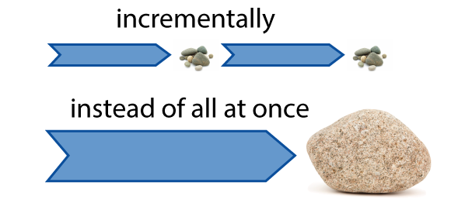

**Figure 1**. What is Agile?. From *agile nut shell*. (http://www.agilenutshell.com/).

The article also states that Agile narrow down the project into several tasks and add them into a functional list which is called a user stories list. Next, the tasks are prioritized, and the development cycle called **iterations** is started, which duration is two weeks. After that, the small version of the project is continually delivered at the end of every iteration (*Agile Definition*, n.d.).

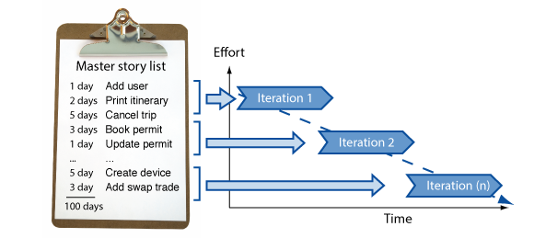

**Figure 2**. What is Agile?. From *agile nut shell*. (http://www.agilenutshell.com/).

# Tasks list

## Set Up Environment

Software and Other features Installation

## Xcode

We installed the latest version of XCode (V 11.7) to develop both AR and Non-AR App.

## Cocoa pod

The article “CocoaPods” (n.d.) states that it plays as a service which is widely used to install several external thousands of libraries for both Swift and Objective-C projects. The benefit of the cocoa pod is that libraries can install or remove from the projects conveniently. **Sudo code** is used to install cocoa pod, and the cocoa pod installation example is mentioned below (CocoaPods, n.d.).

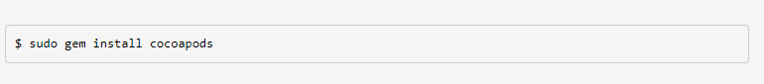

**Figure 3**. What is Cocoapods. From *Cocoapods*. (https://cocoapods.org/).

## Control and Centralize Source Code

It is important to control the source code nicely in software development and development team. Therefore, we choose Git hub as code version control to manage and share the source code with other members. Additionally, we create two repositories for both non-AR and AR apps. In fact, Git hub offers both private and public host services, and git hub offers a private repository for a free account which enormously attract developers and teams across the world to use git hub for development. (Git Hub Definition, n.d.).

# **Setup Database Environment**

## **Cloud Firestore**

Firestore is one of the features of the firebase service offered by Google (Cloud Firestore, n.d.). The article defines Cloud Firestore is a No SQL database which use documents to store data instead of a table. However, there is a collection layer which wraps all the documents to store data and to query. Moreover, the document accepts various types of data and fire store support a more excellent performance in querying. Fire store is easily accessible through client-based and web-based application, mobile application including IOS, Android, native Node.js (Cloud Firestore, Firebase, n.d.).

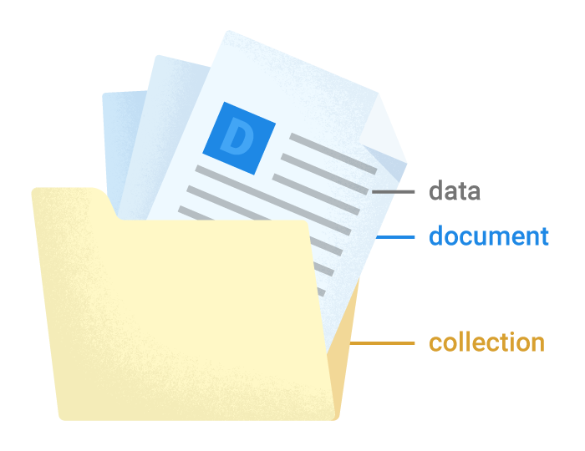

**Figure 4**. Cloud Firestore. From *firebase*. (https://firebase.google.com/docs/firestore). Copyright 2020 by Firebase Google.

# Repository Pattern

The article “Implement the Repository Pattern” (n.d) defines Repository pattern is one of the unique patterns in developing organization level application. Repository pattern does not allow developers to access the data from database straightaway within the application, and it forced to add additional layers like database layer, business logic layer, user interface layer to access the data (Implement the Repository Pattern, n.d.).

# SwiftUI

The article “Learn SwiftUI?” (n.d.) states that IOS developers used storyboard and interface builder to create UIs of IOS application in XCode. Whereas every UI component like table views, buttons, input text must drag and drop into the storyboard and then access those components from the backend side. Although this development process was pretty good that time, apple brings Swift UI with IOS 13 together to change the user interface decoration of apple applications (Learn SwiftUI?, n.d.).

Swift UI is a user interface tools which allow IOS developers to decorate IOS application in a declarative approach (A Free SwiftUI, n.d.).

Starting from IOS 13, Apple allows developers to develop user interface (UI) entirely with Swift UI using swift code from the backend for IOS application. Moreover, IOS developers can use Swift UI and develop user interfaces (UI) on various apple operating system like macOS, watchOS and IOS (Learn SwiftUI?, n.d.).

# Test-driven development (TDD)

The article “Test Driven Development (TDD)” (n.d.) defines TDD is a program development method, whereas test functions are created to check and verify the functionality of the code. In other words, testing procedures are developed for individual functions and examined the functions. When the functional test is failed, the developer fixes the code and retest until the functional test is passed. The objective of TDD is to provide efficient and error-free code (Test Driven Development (TDD), n.d.) .

The article indicates the first step of TDD method is designing and building test functions or unit tests to check and verify every single function of the applications. In test-driven development method, software engineer does not require to add additional code every time except the time when the automated checking is failed. Therefore, the developer initially modifies the code when the code is failed during the test. This practice will protect from writing the same code, reduce the line of codes and solid the structure of code in the application (Test Driven Development (TDD), n.d.).

TDD can address as **Test First Development method** alternatively because TDD method includes the procedure of creating and testing the code automatically advance before starting any real development work of the application (Test Driven Development (TDD), n.d.).

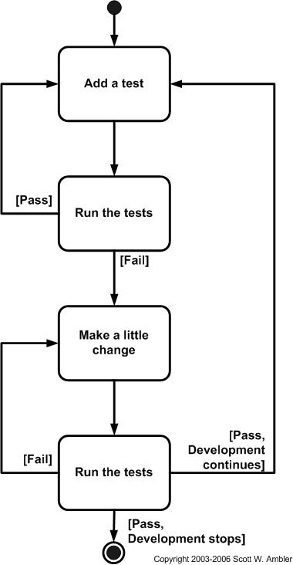s

**Figure 6**. Test-driven development. From *Test Driven Development (TDD).* (https://www.guru99.com/test-driven-development.html).

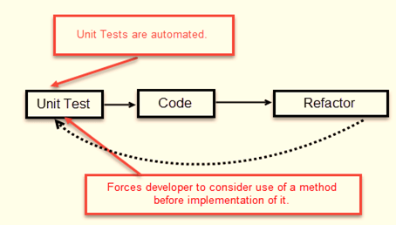

**Figure 7**. Unit Test with Test-driven development. From *Test Driven Development (TDD).* (https://www.guru99.com/test-driven-development.html**)**

# Implementation

## Asset

To Implement both AR and non-AR Furniture Shopping applications, we downloaded different free resources from the internet:

* Free 3D Models provided by Apple in their ARKit tutorials (“Placing Objects and Handling 3D Interaction,” n.d).
* Icons and stickers are downloaded from flaticon.com.
* Content, price, images of furniture are downloaded from Google.

## Design Pattern

### Model-View-Controller (MVC) and Model-View-ViewModel (MVVM)

We combine both MVC and MVVM in the same project. Particularly, MVC is to implement AR functions, while MVVM is to develop the remaining the non-AR functions.

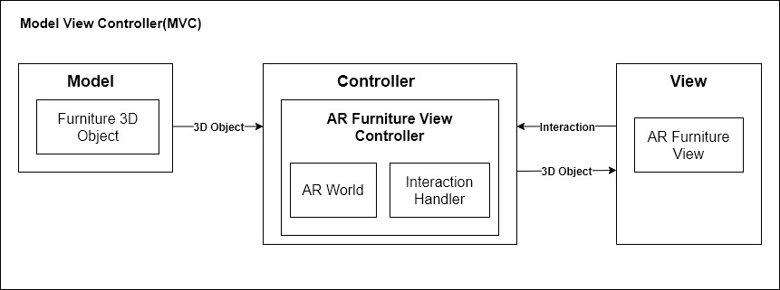

**Figure 8.** AR Kit Furniture Model View Controller (MVC) Design

The MVC pattern is shown in Figure 8, class ARFurnitureView is to render the ARWorld with 3D objects and planes. While class ARFurnitureViewController is to process business logic, send data to view, and listen the event from ARWorld. The class Furniture3DObject is to contain 3D model information.

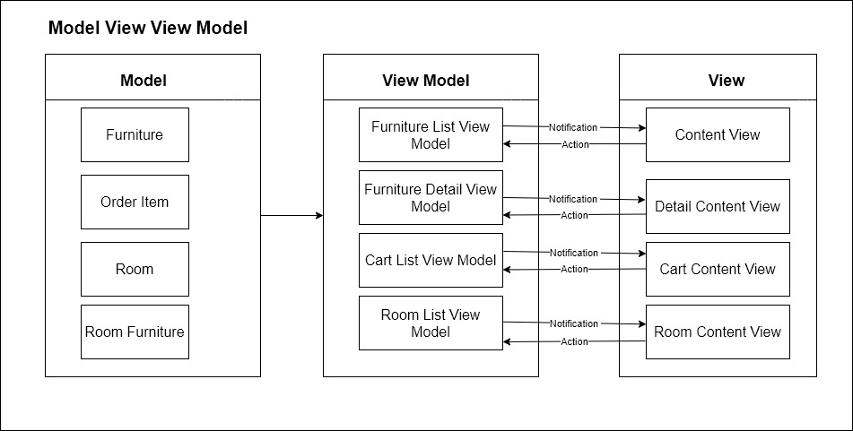

**Figure 9**. AR Kit Furniture Repository Pattern

The MVVM pattern is shown in Figure 9, each view has corresponding view models to listen notifications of data changes, and send actions. For example, DetailContentView is to show furniture detail, and it listens to FurnitureDetailViewModel for any data change events. Also, when users click Add To Cart, DetailContentView will dispatch an action to FurnitureDetailViewModel. The model class Furniture is only to contain furniture detail information.

### Repository Pattern

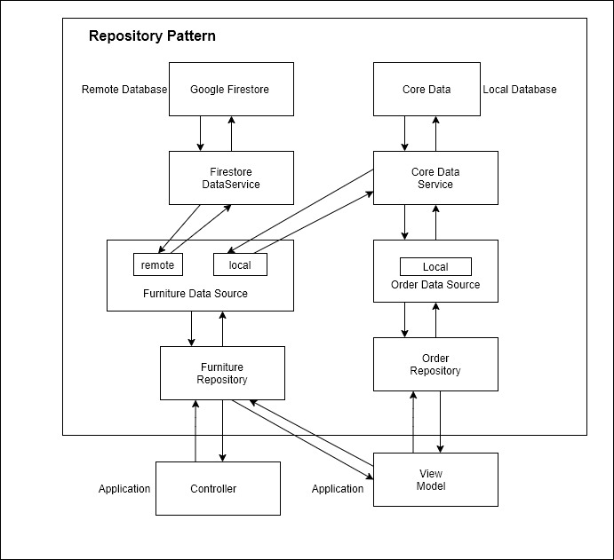

**Figure 10**. AR Kit Furniture Repository Pattern

As shown in Figure 10, both controllers and view models interact to Data Storages by FurnitureRepository and OrderRepository. Particularly, FurnitureRepository has both local and remote data sources, while OrderRepository only has local data source. Furthermore, these data sources interact to remote database by FirestoreDataService, and local database by CoreDataService.

## Test Driven Development

We follow TDD in most of the non-AR functions but not AR features because of the ARKit complexity in writing unit test. Mainly, before implementing a feature, we prepare few unit tests to cover its scenarios as much as possible. After that, the code is added to pass those unit tests. While writing unit tests, we created mock functions and instances to avoid dependencies. As shown in Figure 11, a unit test for testing the number of items in Cart after clicking Add To Cart. We create a fake SwiftUI view of DetailBodyView class, and its fake model view fakeFurnitureDetailModel. After that we use the ViewInspector framework to simulate a click event. Finally, we check local database to compare the number of ordered items with the number in fakeFurnitureDetailModel.

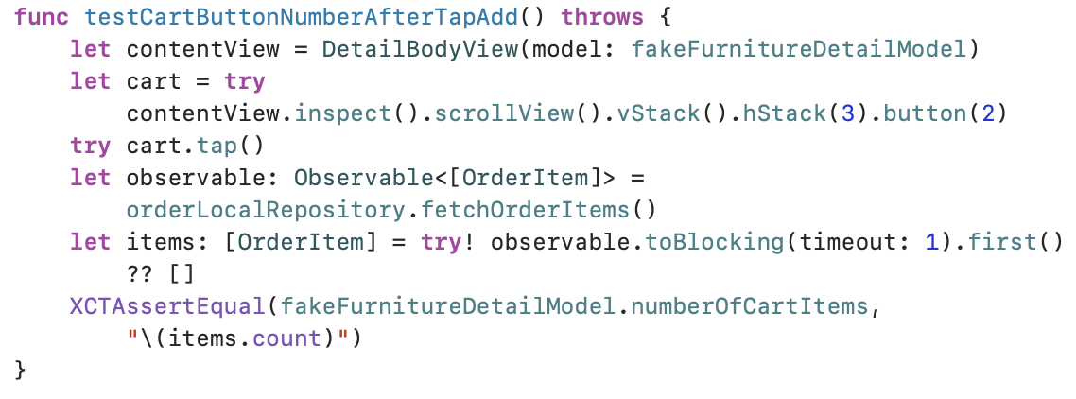

**Figure 11**. An unit test for Add To Cart.

As shown in Figure 12, we finished total 48 unit tests and all of them passed.

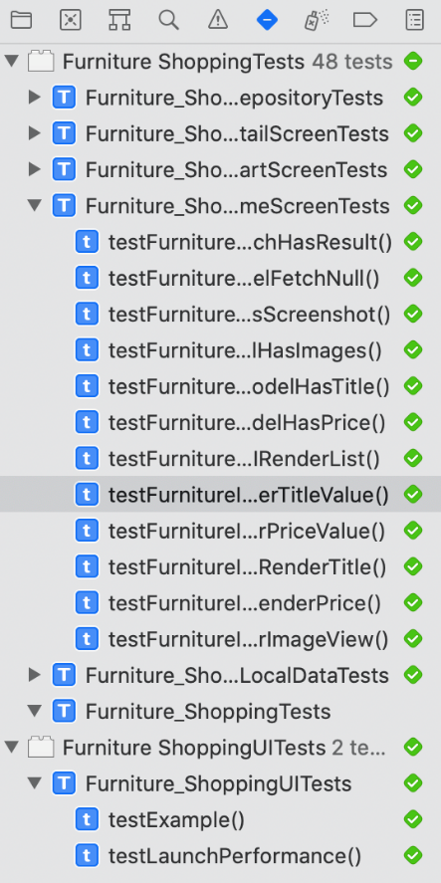

**Figure 12**. The number of unit tests in project.

## Load 3D model

As shown in Figure 13, 3D models are placed on remote database (Firestore). They are zip files that contain a scn file (3D virtual object) and a JSON file to describe model properties.

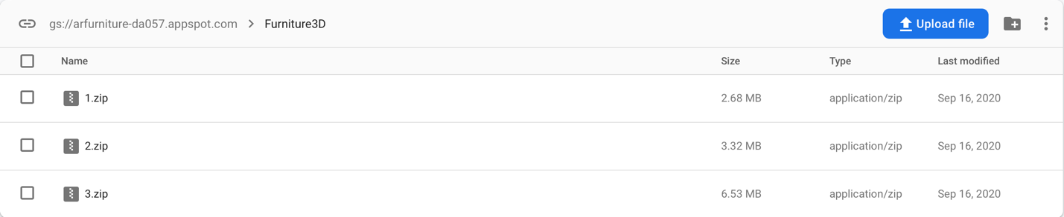

**Figure 13**. 3D models on Firestore.

As shown in Figure 14, we use Firebase’s Storage service to download zip files then unzip by ZipFoundation framework in Figure 15.

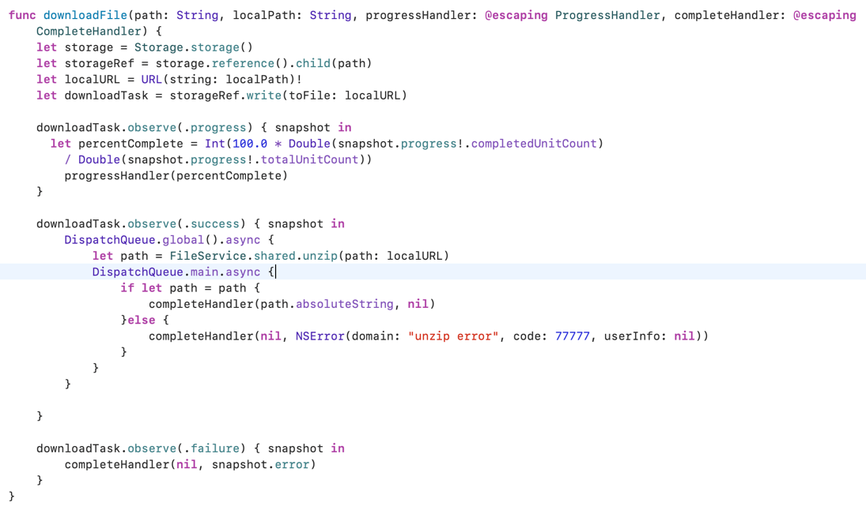

**Figure 14**. Download 3D Model zip files.

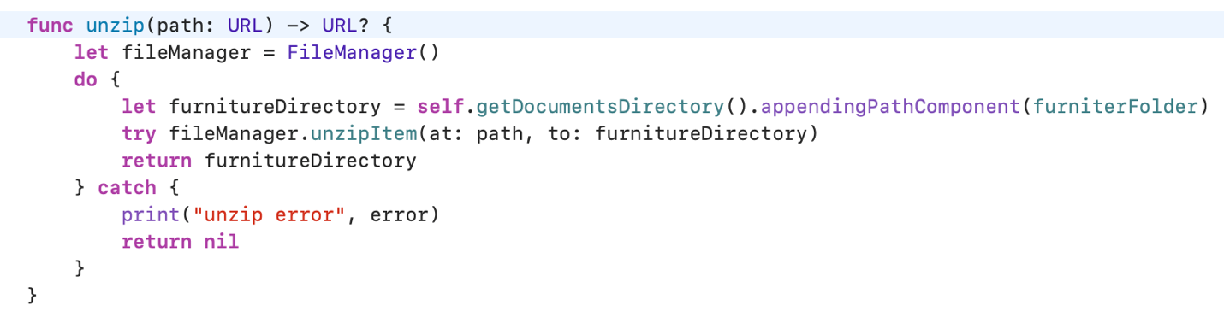

**Figure 15**. Unzip a file.

As shown in Figure 16, we load the 3D virtual object from downloaded file by allocating an instance of Furniture3DObject then we assign properties from JSON to this instance such as name, body, placeholder, and size.

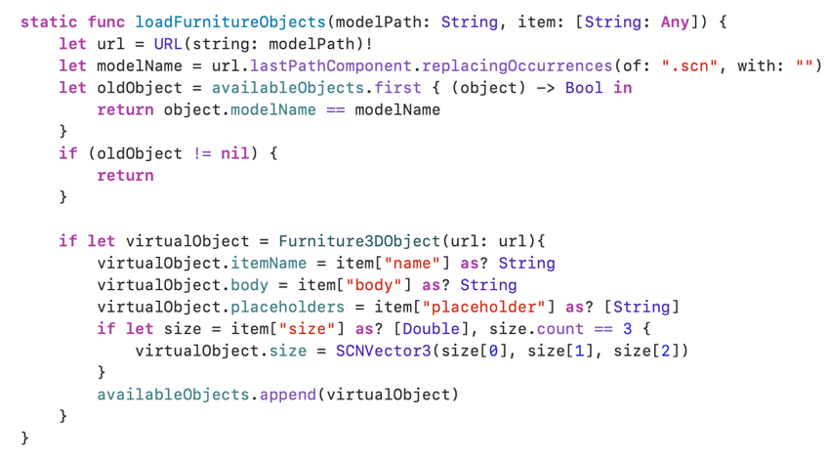

**Figure 16**. Load a furniture 3D model.

As shown in Figure 17, Furniture3DObject inherits from Scenekit ‘s SCNReferenceNode to render virtual object.

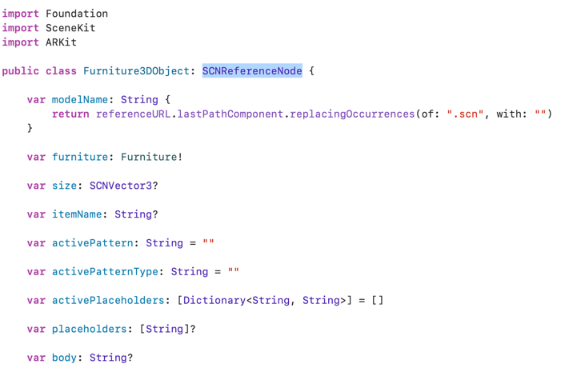

**Figure 17**. Furniture3DObject.

As shown in Figure 18, we add the Furniture3DObject to the scene to display it on devices.

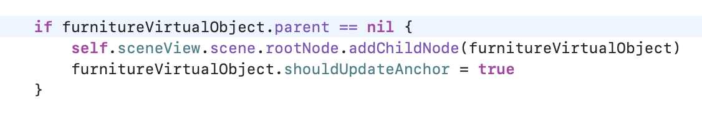

**Figure 18**. Add 3D model to scene.

## Move and Rotate 3D model

As shown in Figure 19, we monitor the Pan Gesture to calculate the new position on 2D screen. Then we map 2D position to 3D position in ARWorld by creating a ARRaycastQuery as shown in Figure 20. After that we update the simWorldPosition and simWorldOrientation of the virtual object for moving (Figure 21).

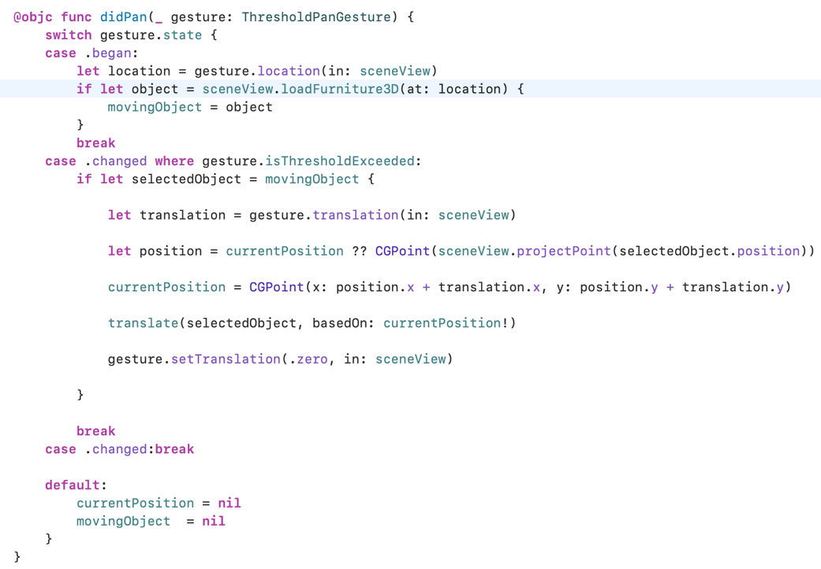

**Figure 19**. Monitor Pan Guesture.

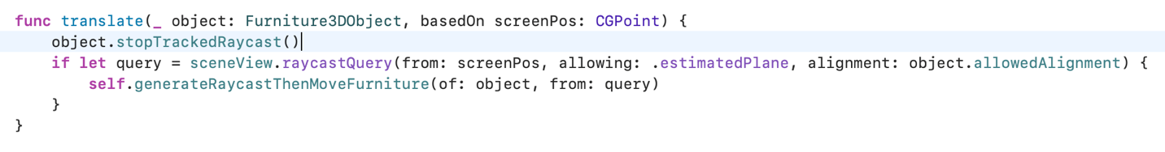

**Figure 20.** Map 2D to 3D position.

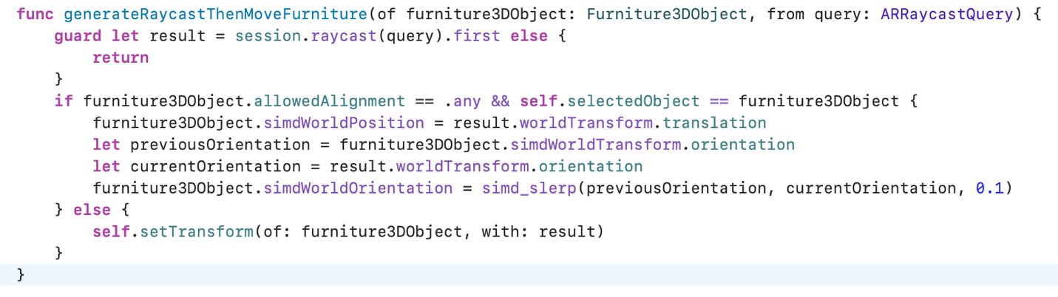

**Figure 21**. Move 3D model to new position in ARWorld.

As shown in Figure 22, to rotate the 3D furniture model, we monitor the Rotation Gesture then update the y axis of the 3D model (Figure 23).

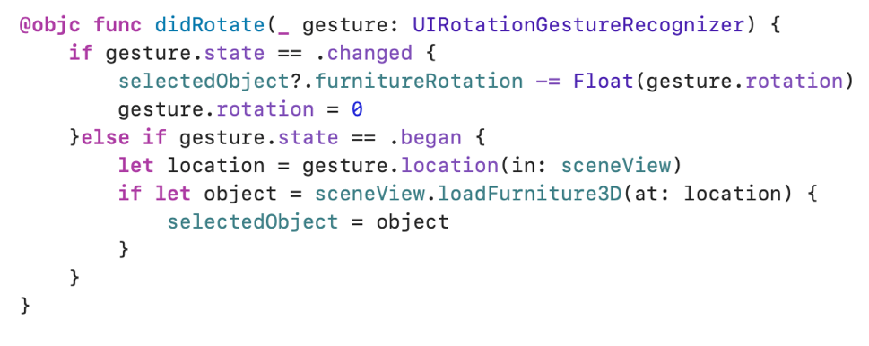

**Figure 22**. Monitor Rotation Gesture.

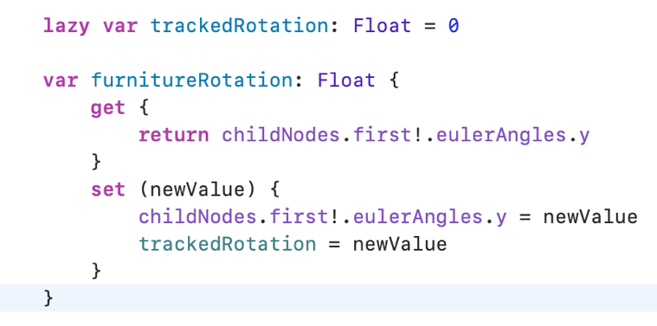

**Figure 23.** Update y axis of 3D model.

## Capture Screenshot

As shown in Figure 24, we capture the screenshot by calling snapshot method of ARSCNView, the screenshot is saved to local folders by FurnitureRepository.

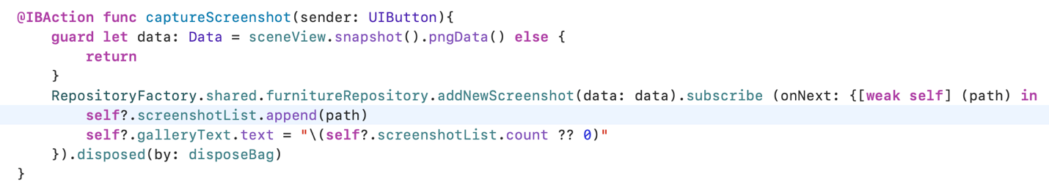

**Figure 24**. Take screenshot.

## Change 3D model pattern

There are two pattern types in our applications, the first type is Color and the remaining type is Texture. Firstly, we determine the body part of a 3D model by assigning body tag for that part in Xcode (Figure 25). After that, we look for the body Node by the method childNode, then update Color and Texture by changing material of that node (Figure 26).

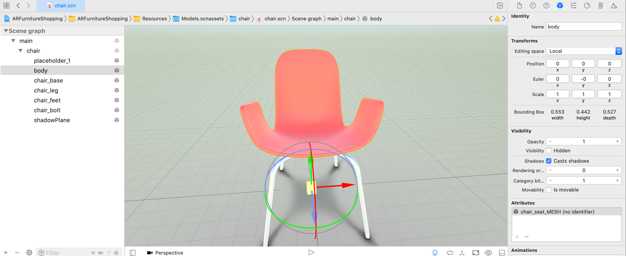

**Figure 25**. Assign body tag by Xcode.

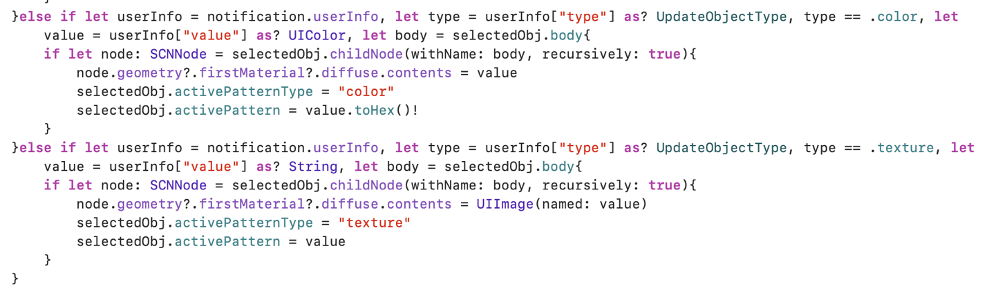

**Figure 26**. Update body patterns.

## Add Stickers to 3D model

To add stickers to a 3D model, we implement three steps:

* Modify a 3D model by Blender to create a node that stickers can be integrated (Figure 27).
* Assign an unique identifier that has the pefix “placeholder_” such as placeholder_1, placeholder_2 to the placeholder nodes (Figure 28).
* Look for the nodes that have “placeholder_” tags by the method childNode, then update their materials by stickers (Figure 29).

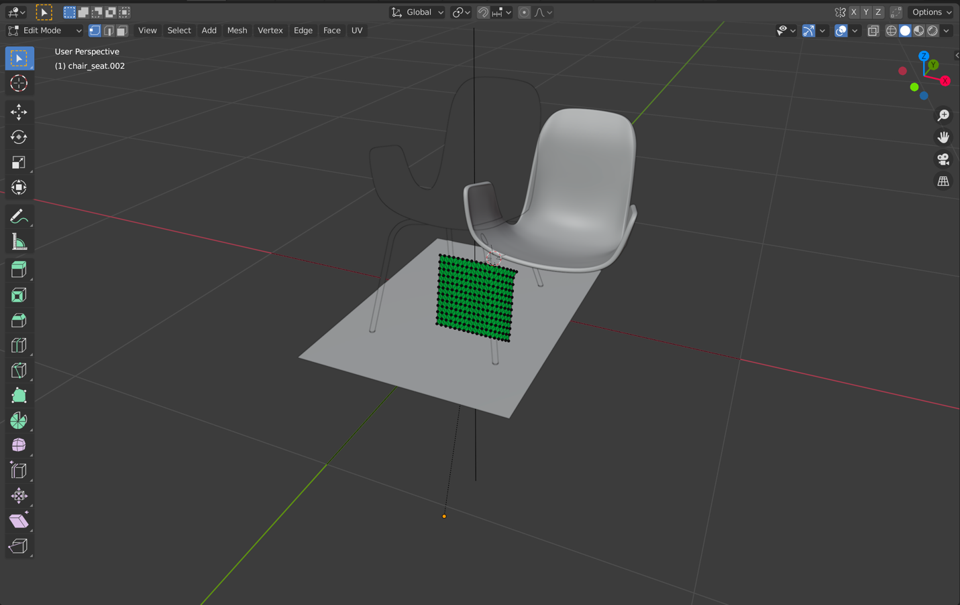

**Figure 27**. Create placeholder nodes by Blender.

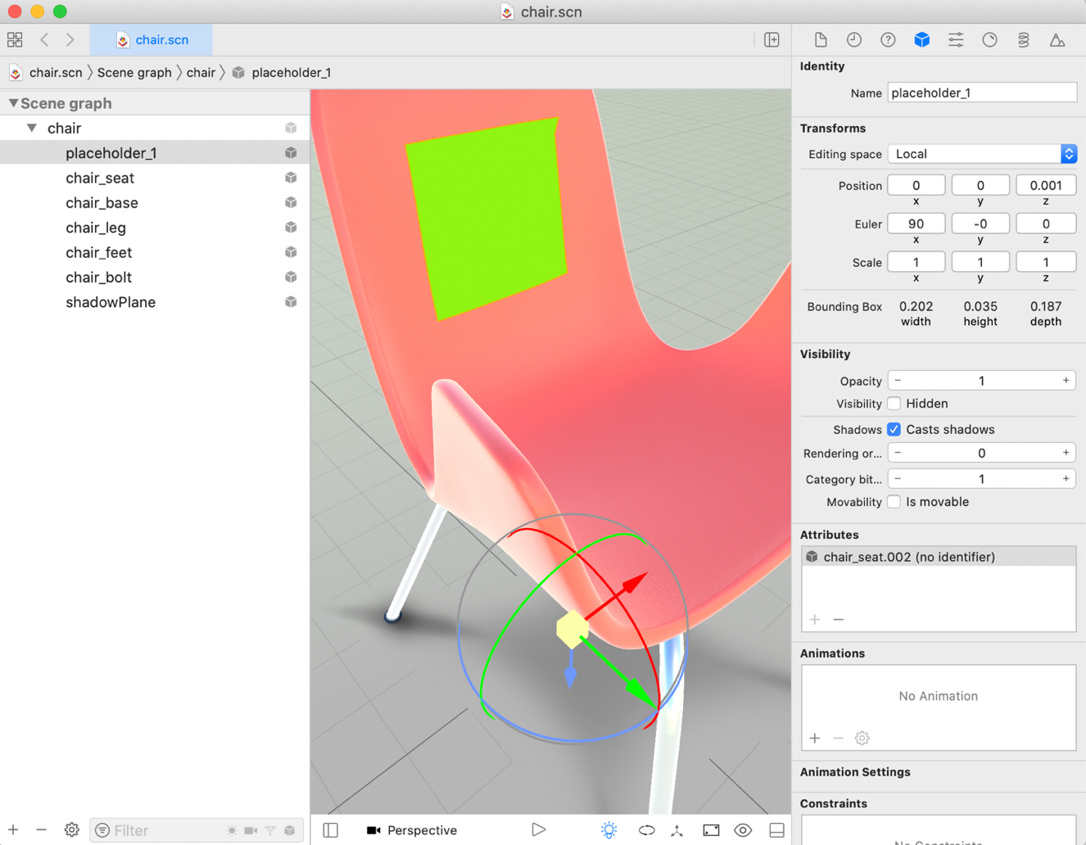

**Figure 28**. Assign unique tag for placeholder nodes.



**Figure 29**. Update placeholder patterns.

## Save and Load Room

To save a room with 3D furniture models, we implement two steps:

* Encode the ARWorldMap to binary data by NSKeyedArchiver, and take the current screenshot by snapshot method. Then we save both files into local folder (Figure 29).
* Use FurnitureRepository to save current status of 3D models such as rotation, patterns, and stickers. These information are saved to local database.

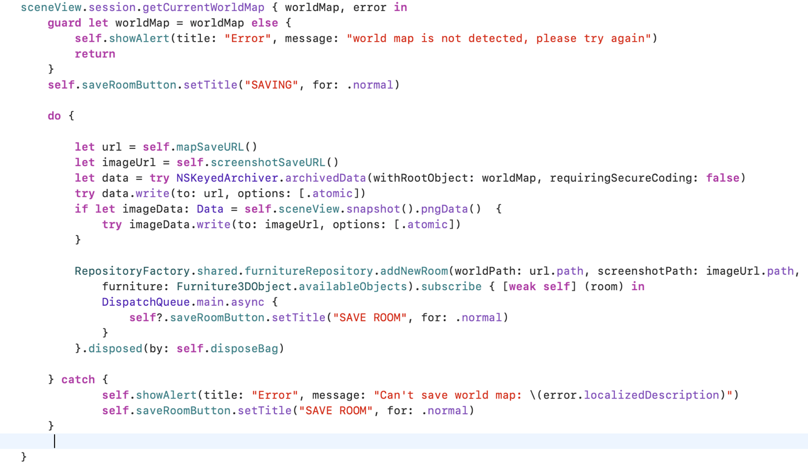

**Figure 29**. Save room data to local folder.

To load a saved room with 3D furniture models, we implement these steps:

* Recover the saved binary file of ARWorldMap by unarchivedObject method of NSKeyedUnarchiver (Figure 30).
* Restart the current session of scene by the recovered ARWorldMap instance (Figure 31).
* Monitor the renderer event of ARSCNView (Figure 32) to load saved furniture 3D models (Figure 33).
* After a furniture 3D model is loaded, we reconstruct its stickers, color, texture, and rotation by data from local database. Then it is added to the root node for displaying on ARSCNView (Figure 34).



**Figure 30**. Load an archived ARWorldMap.

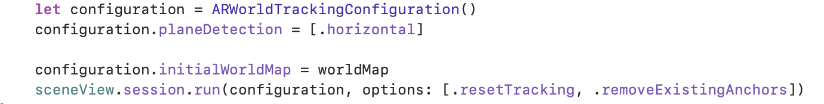

**Figure 31**. Restart session by loaded ARWorldMap.



**Figure 32**. Listen renderer event after session restarted.

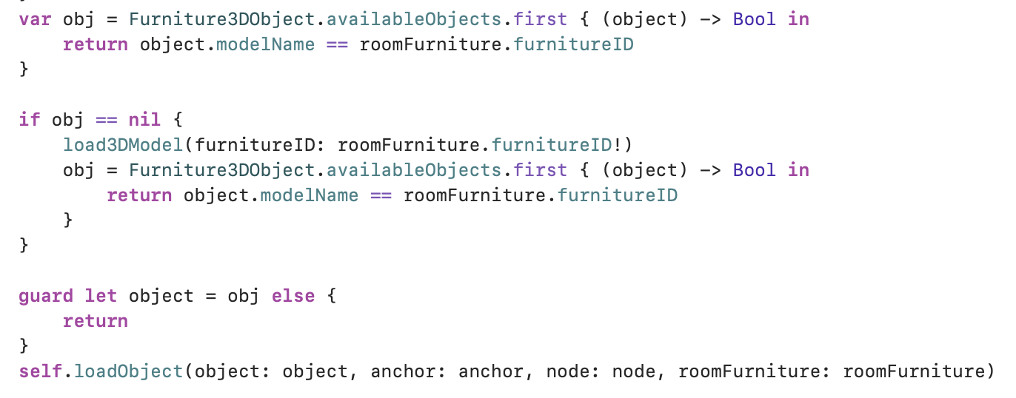

**Figure 33**. Load saved 3D model after session restarted.

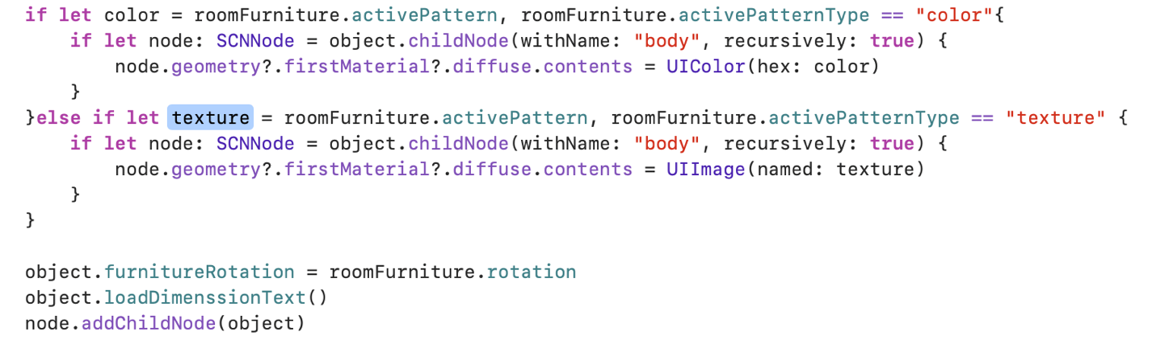

**Figure 34**. Update model pattern and display on screen.

## Display Model Dimension

As shown in Figure 35, we get the size property of a 3D model then display these information by creating SCNText, and put these texts onto the 3D model.

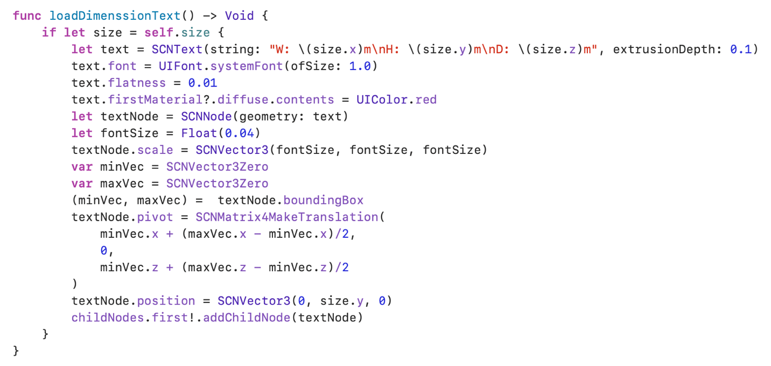

**Figure 35**. Add text onto a furniture 3D model.

# Result

## Furniture List

The furniture list of the non-AR app and AR app in Figure 36. Particularly, AR app has Room button at top left.

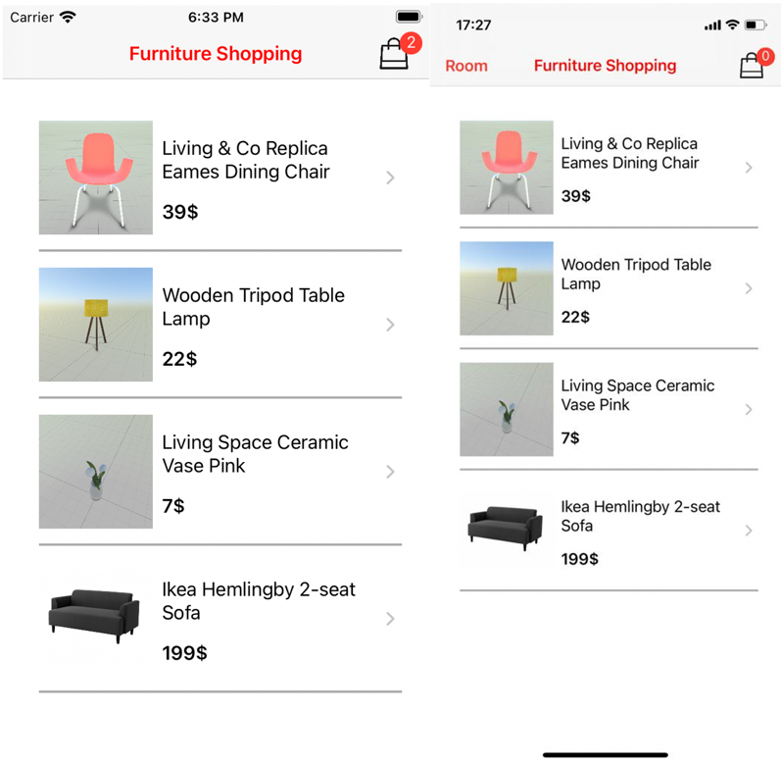

**Figure 36.** Furniture list

## Furniture Detail

As shown in Figure 37, the furniture detail of the non-AR app has a slide show.

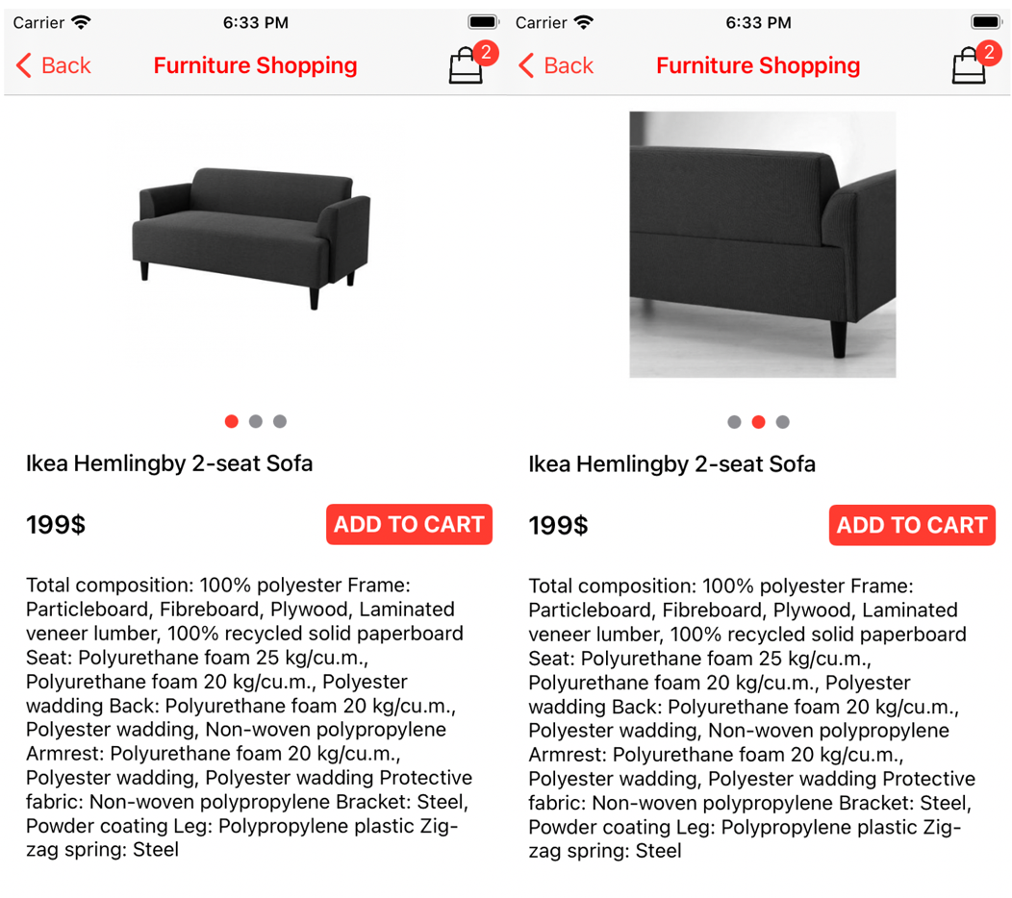

**Figure 37**. Furniture Detail of the non-AR app.

As shown in Figure 38, the furniture detail of AR app is same as the non-AR app but it has 3D Mode button to enter ARWorld.

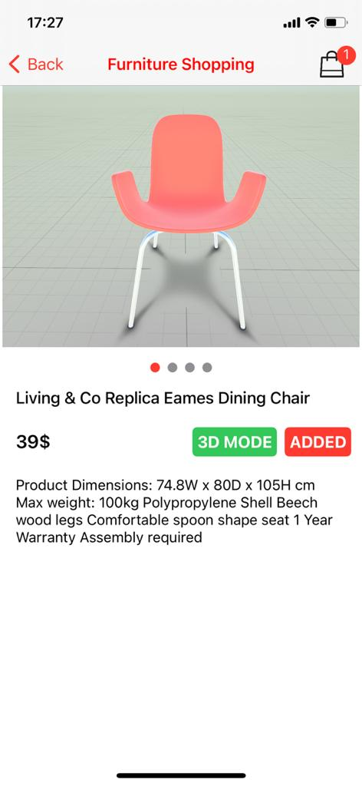

**Figure 38**. Furniture detail of AR app.

## Cart Screen

As shown in Figure 39, the Cart screen is same as AR and non-AR apps.

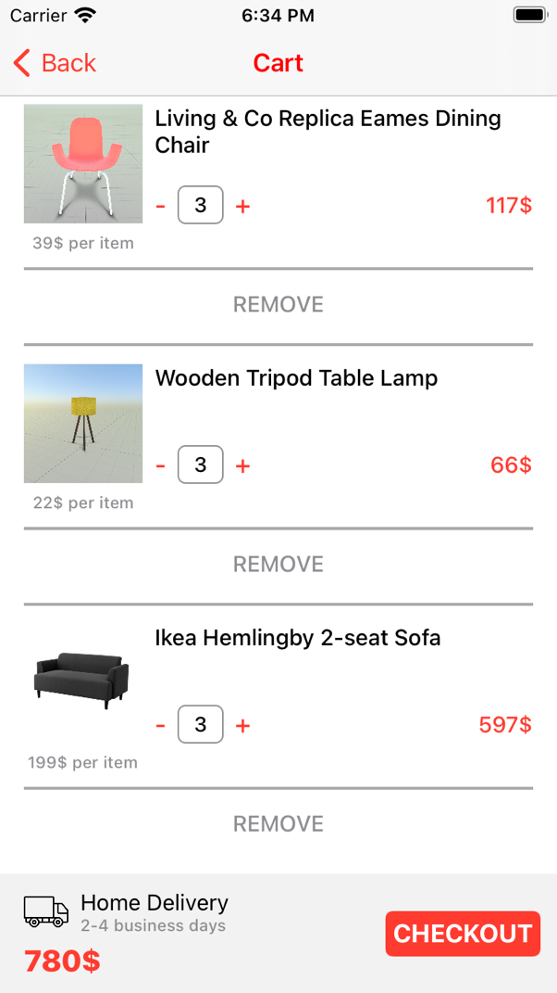

**Figure 39**. Cart screen

## Send Email

As shown in Figure 40, the function Send Email for purchasing is same in both AR and non-AR apps.

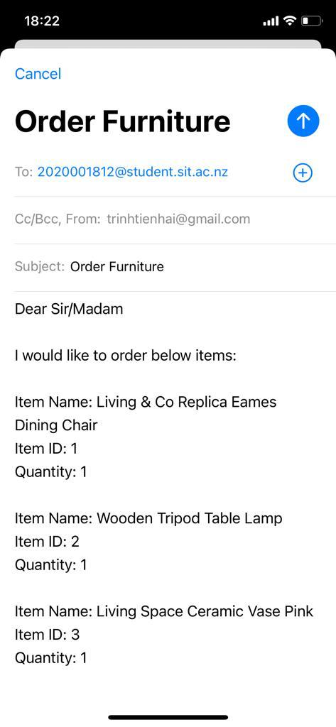

**Figure 40**. Send email function.

## Place 3D Furniture Model

As shown in Figure 41, we select furniture 3D models from a list then click Add to place furniture. In Figure 42, all 3D models are placed in plane and a table, and the size of these models are real.

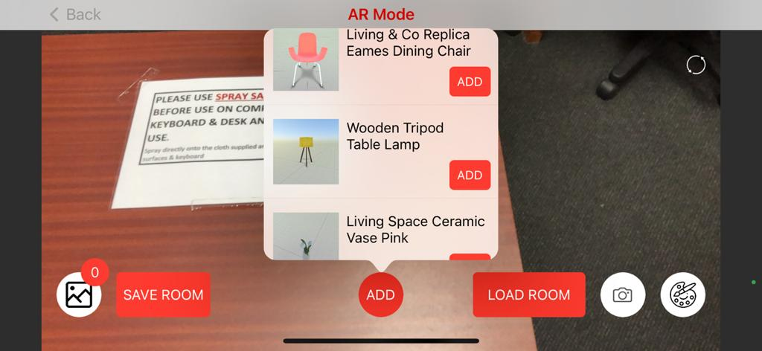

**Figure 41**. Select 3D models.

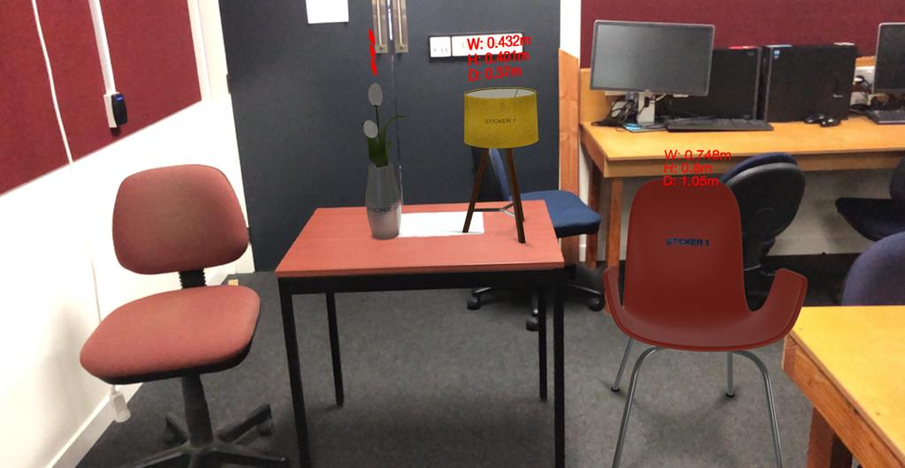

**Figure 42**. Place 3D models.

## Update Patterns and Stickers

As shown in Figure 43, 44, and 45, we can select texture, color, and stickers from popup. The result of these selections are shown in Figure 46.

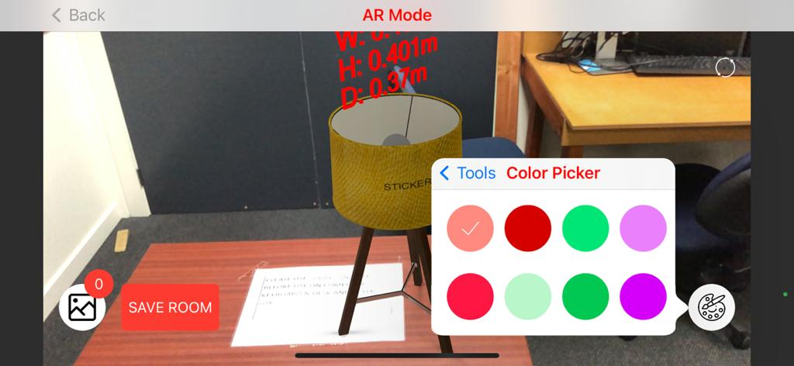

**Figure 43**. Select Color.

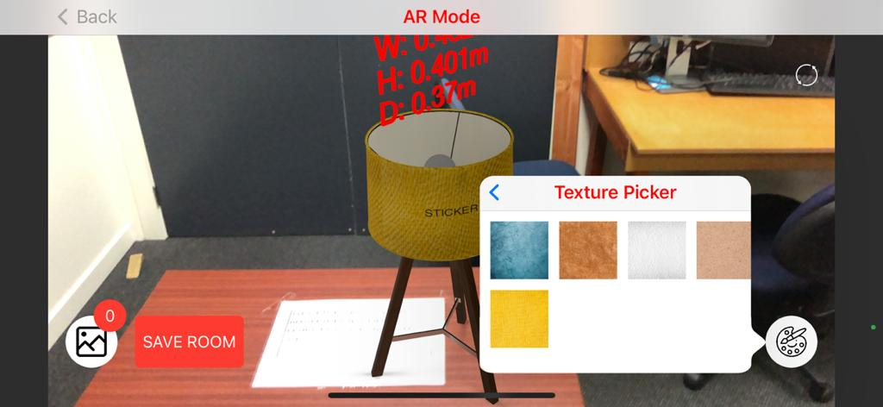

**Figure 44**. Select Texture.

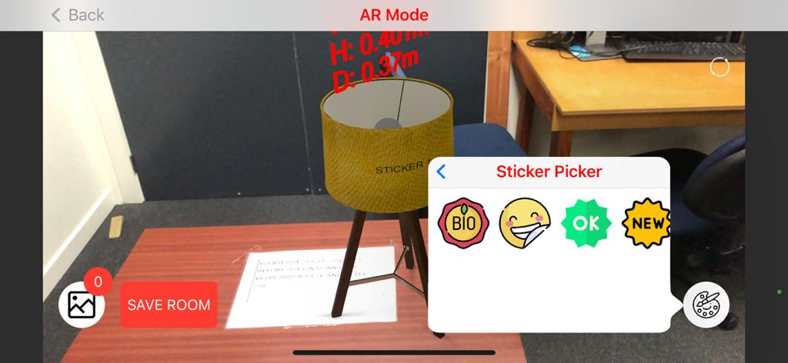

**Figure 45**. Select Stickers.

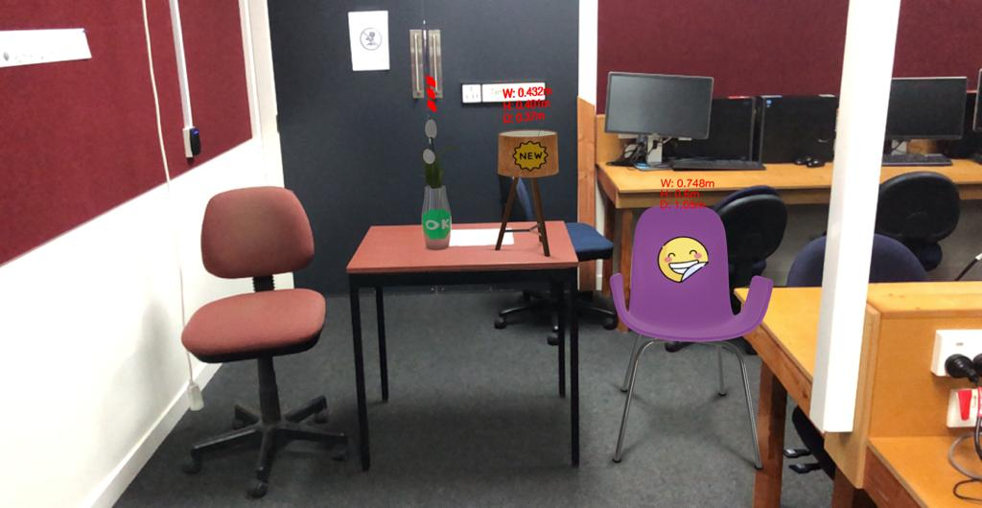

**Figure 46**. Result of changing patterns.

## Moving and Rotating 3D models

As shown in Figure 47, the chair is moved and rotated.

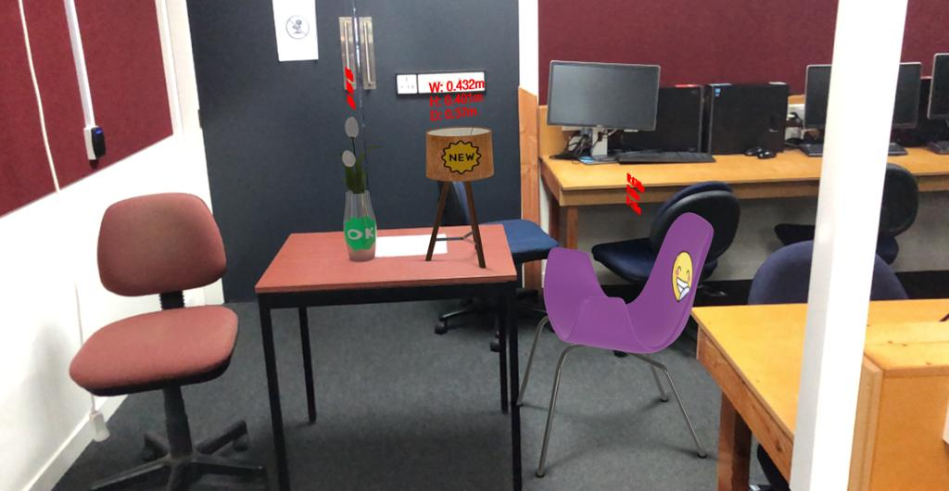

**Figure 47**. Move and Rotate 3D objects.

## Take Screenshot

As shown in Figure 48, click camera button will take screenshot of the current scene, and it also increase the badge number of gallery button. Then click gallery button is to open gallery which contains all screenshots (Figure 49), and in gallery has Save All to export all screenshots to Photo Library.

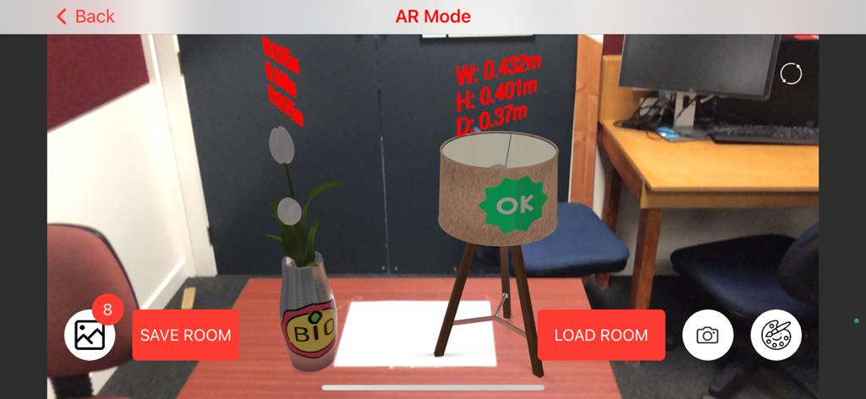

**Figure 48**. Take screenshot.

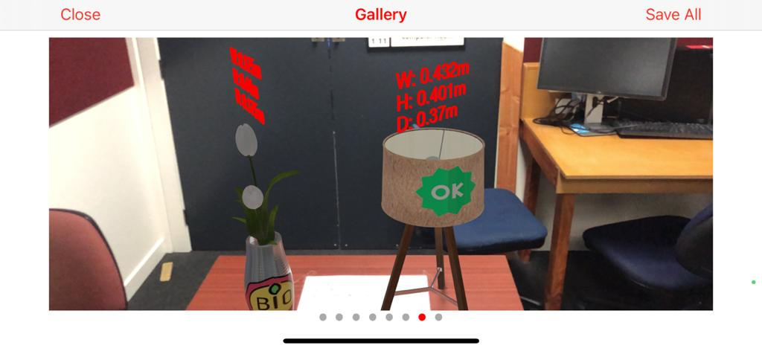

**Figure 49**. Gallery.

## Save and Load Room

The Save Room button as shown in Figure 48, after a room is saved, it will be put in a list in Figure 50. As shown in Figure 51, the room is ready to load, and then Figure 52 shows a room that is loaded successfully.

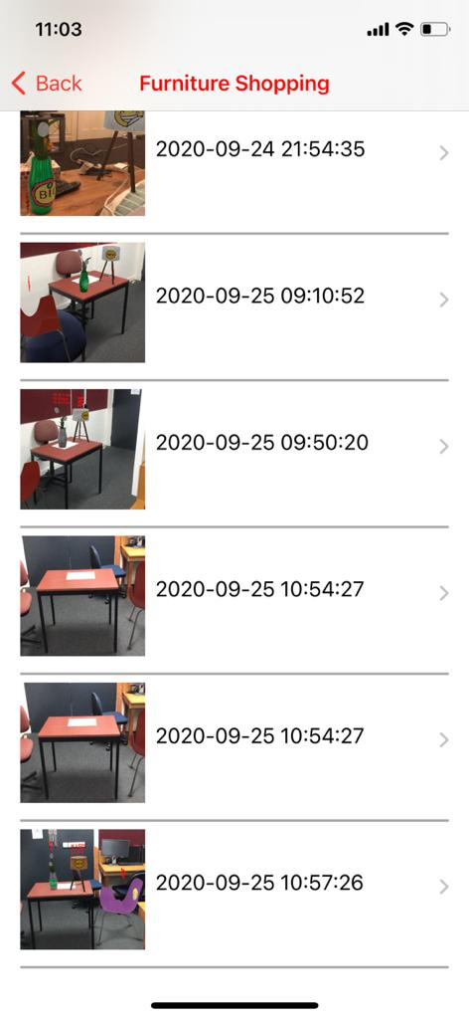

**Figure 50**. Saved rooms list.

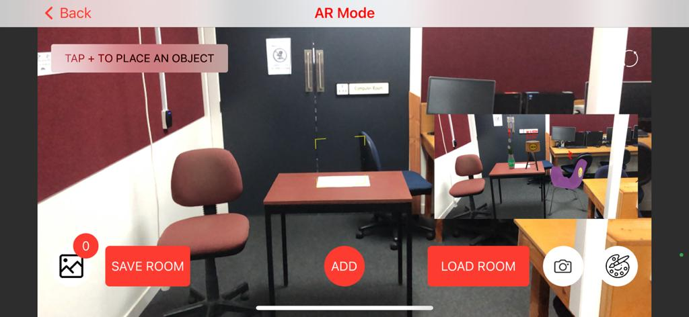

**Figure 51**. Prepare to load room.

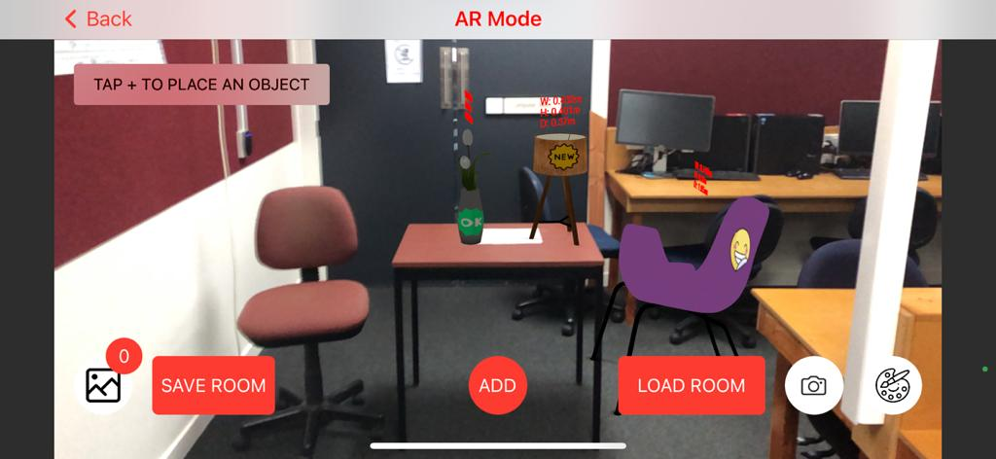

**Figure 52**. Load room successfully.

# Conclusion

To conclude, we implemented both AR and non-AR apps successfully. Particularly, these apps provide sufficient features for users to browse, select, and purchase furniture. The AR features also allow us to experience the virtual furniture in a real room with the ability to customize the furniture patterns. Furthermore, The app can save the room and its virtual furniture for future use to enrich the user experience in purchasing furniture.

TDD was followed thoroughly in developing non-AR functions that improve these features' quality regarding the development process. However, we did not apply TDD for AR functions because of their complexities. We also applied three design patterns Repository, MVC, and MVVM that make the project code clear and scalable.

# References

A free SwiftUI. (n.d.). Retrieved September 23, 2020, from https://www.hackingwithswift.com/quick-start/swiftui/what-is-swiftui

Agile Definition. (n.d.). Retrieved September 23, 2020, from http://www.agilenutshell.com/

Cloud Firestore, Firebase. (n.d.). Retrieved September 23, 2020, from https://firebase.google.com/docs/firestore

Cloud Firestore. (n.d.). Retrieved September 23, 2020, from https://www.codemag.com/Article/1905071/Introduction-to-Cloud-Firestore

CocoaPods. (n.d.). Retrieved September 23, 2020, from https://cocoapods.org/

Git Hub Definition. (n.d.). GitHub. Retrieved September 23, 2020, from https://github.com

Implement the Repository Pattern. (n.d.). Retrieved September 23, 2020, from https://www.infragistics.com/community/blogs/b/dhananjay_kumar/posts/how-to-implement-the-repository-pattern-in-asp-net-mvc-application

Learn SwiftUI. (n.d.). Retrieved September 23, 2020, from https://www.adjust.com/blog/get-started-with-swiftui/

Muntenescu, F. (2016, November 4). Android Architecture Patterns Part 3: Model-View-ViewModel. Medium. https://medium.com/upday-devs/android-architecture-patterns-part-3-model-view-viewmodel-e7eeee76b73b

MVVM Explained. (2014, April 24). Wintellect. https://www.wintellect.com/model-view-viewmodel-mvvm-explained/

Placing Objects and Handling 3D Interaction. (n.d.). Retrieved September 1, 2020, from https://developer.apple.com/documentation/arkit/world_tracking/placing_objects_and_handling_3d_interaction

Test Driven Development (TDD). (n.d.). Retrieved September 23, 2020, from https://www.guru99.com/test-driven-development.html

Test Driven Development. (n.d.). Retrieved September 23, 2020, from http://agiledata.org/essays/tdd.html